VULNERABILITY ASSESSMENT & PENETRATION TESTING — FINDING REPORT
6. Improper Session Management
Privilege Escalation via Client-Side Cookie Tampering
Target | SecureCorp Employee Portal — http://192.168.155.129
Lab Platform | TryHackMe — TuteDude Cybersecurity Track
Application Build | Portal v1.0.1-beta · Backend v2.0.4-LTS · Legacy-JS-Lib v0.4
Vulnerability Class | Improper Session Management (Broken Access Control)
Overall Severity | Critical
Tester | Farhan
Date of Testing | August 15, 2026
Flag Captured | FLAG{COOKIE_MANIPULATION_SUCCESS}
Classification | Confidential — Educational / Lab Use Only

Executive Summary
The SecureCorp Employee Portal determines a logged-in user's privilege level from a plaintext, client-writable cookie (user_role) rather than a value resolved server-side from a trusted session store. Because this cookie is never validated or cryptographically bound to the authenticated session, its value can be freely edited in transit. During this assessment, an authenticated low-privilege account was escalated to administrator by intercepting a single request and changing user_role from employee to admin, with no further authentication or checks imposed by the server.
A secondary issue compounded the attack path: the login page's HTML source contained a developer comment disclosing valid onboarding credentials in plaintext, which removed the need for any credential guessing or brute-forcing to obtain an initial authenticated foothold.
Exploitation was demonstrated end-to-end using Burp Suite Community Edition to intercept, inspect, and tamper with live HTTP traffic. Successful escalation was confirmed when the application itself surfaced a high-alert banner containing the objective flag, FLAG{COOKIE_MANIPULATION_SUCCESS}, which was submitted and validated on the lab platform.

Scope & Objective

Lab Objective (as stated)
"Exploit an improper session management vulnerability on the site and capture the flag."

Target
Web application: SecureCorp Employee Portal, reachable at http://192.168.155.129 (internal lab network address).

Tools Used
- Burp Suite Community Edition v2026.7.2 — proxy interception, Repeater, request/cookie tampering
- Chromium-based browser — application walkthrough and view-source inspection
- Browser DevTools / view-source — static HTML review

Findings Summary
# | Finding | Severity | CVSS 3.1 (approx.) | CWE / OWASP
1 | Broken Access Control — client-controlled role cookie allows privilege escalation | Critical | 8.1 (High–Crit.) | CWE-565, CWE-639 · A01:2021
2 | Sensitive information disclosure — credentials hardcoded in HTML comment | High | 7.5 (High) | CWE-615, CWE-798 · A01:2021
CVSS scores are indicative, estimated per the CVSS 3.1 base metric definitions for this finding class.

Detailed Walkthrough
STEP 1 Reconnaissance — Source Review Discloses Credentials
Testing began at the login page, http://192.168.155.129/index.php. A first login attempt was submitted with throwaway credentials purely to capture the request/response pair in Burp Suite. Re-sending that request through Repeater and reviewing the raw HTML response (independently confirmed via the browser's view-source) revealed a developer note left inside the page markup:
<!-- Hey John Welcome onboard use your first name as username and 'babayaga' as your password and remove this comment after you login -->
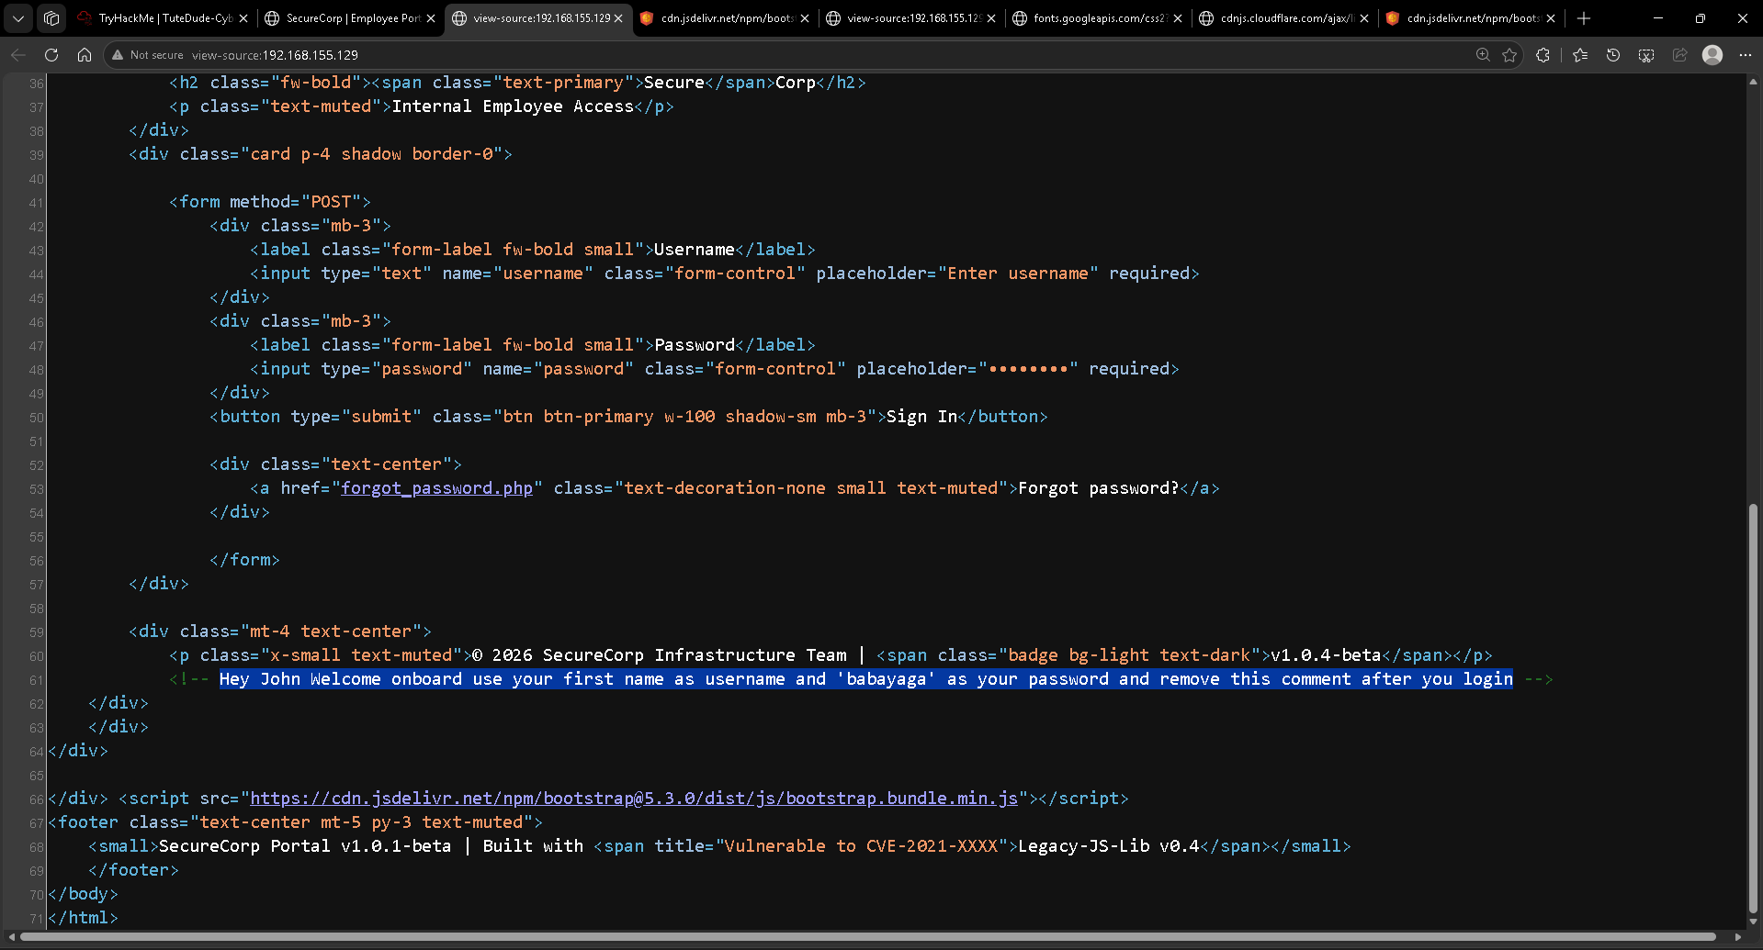
Fig. 1 — index.php source (view-source) with the onboarding-credential comment highlighted.
This comment directly discloses a working credential pair — username john, password babayaga — that was evidently meant to be removed before the application went live.
STEP 2 Authenticating With the Disclosed Credentials
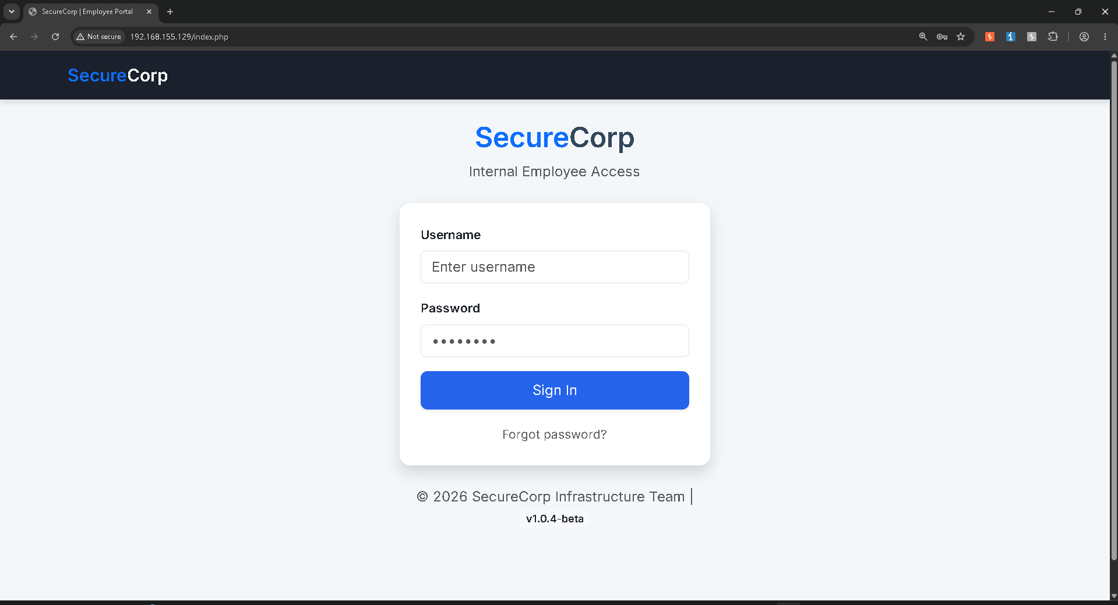
Fig. 2 — Login form populated with the disclosed credentials.
Burp Suite's proxy was switched to Intercept: On to capture the authentication request before it reached the server.
[ screenshot file not retained in upload — described from session capture ]
Fig. 3 — Burp Suite Proxy with Intercept enabled, awaiting the login POST request.
The intercepted request confirmed the exact payload submitted to the server:
POST /index.php HTTP/1.1
Cookie: PHPSESSID=4ougrdo3o8qro128p6tni899vk
username=john&password=babayaga
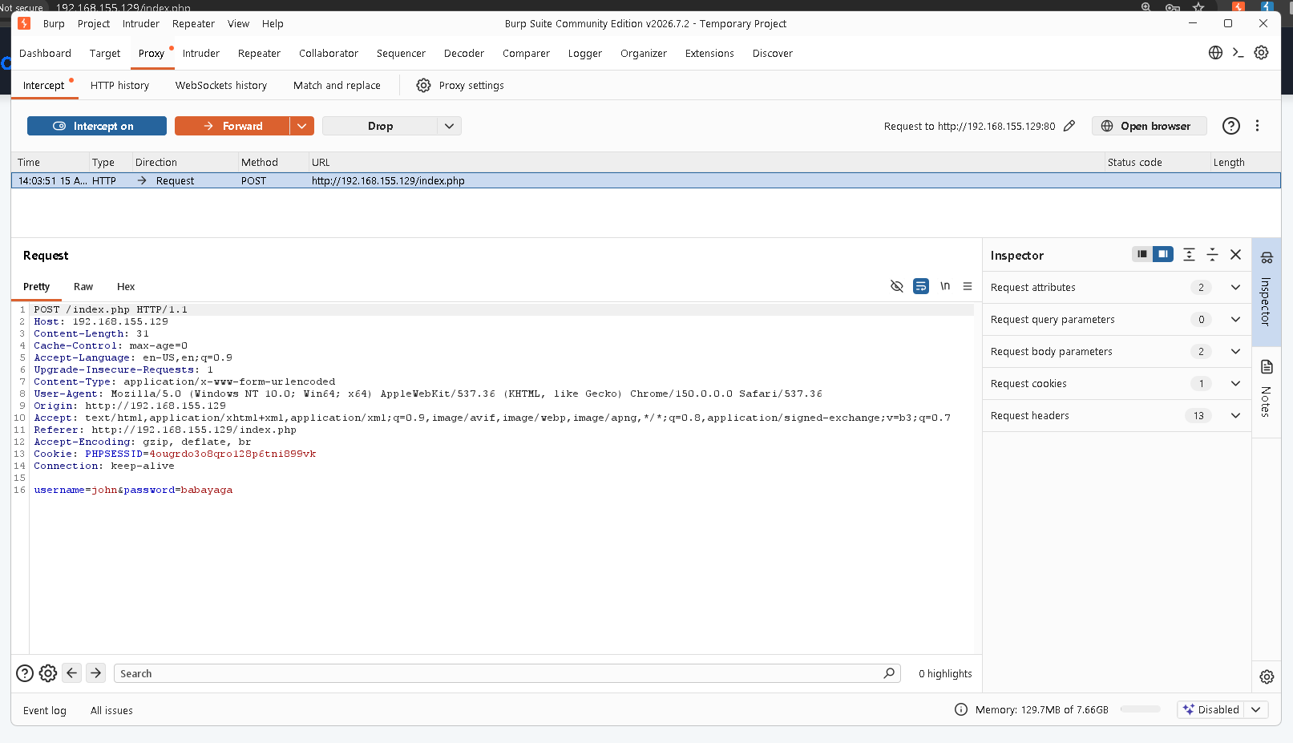
Fig. 4 — Intercepted POST /index.php request showing the login payload.
The request was forwarded and the server accepted the credentials, issuing a session and redirecting to the employee dashboard as user “John.”
STEP 3 Session Analysis — A Second, Meaningful Cookie
Once authenticated, dashboard.php (“Hello, John!”) was reloaded with Burp's intercept active to inspect exactly how the session was represented on the wire. Alongside the expected opaque PHPSESSID identifier, the browser was also sending a second, human-readable cookie:
Cookie: PHPSESSID=4ougrdo3o8qro128p6tni899vk; user_role=employee
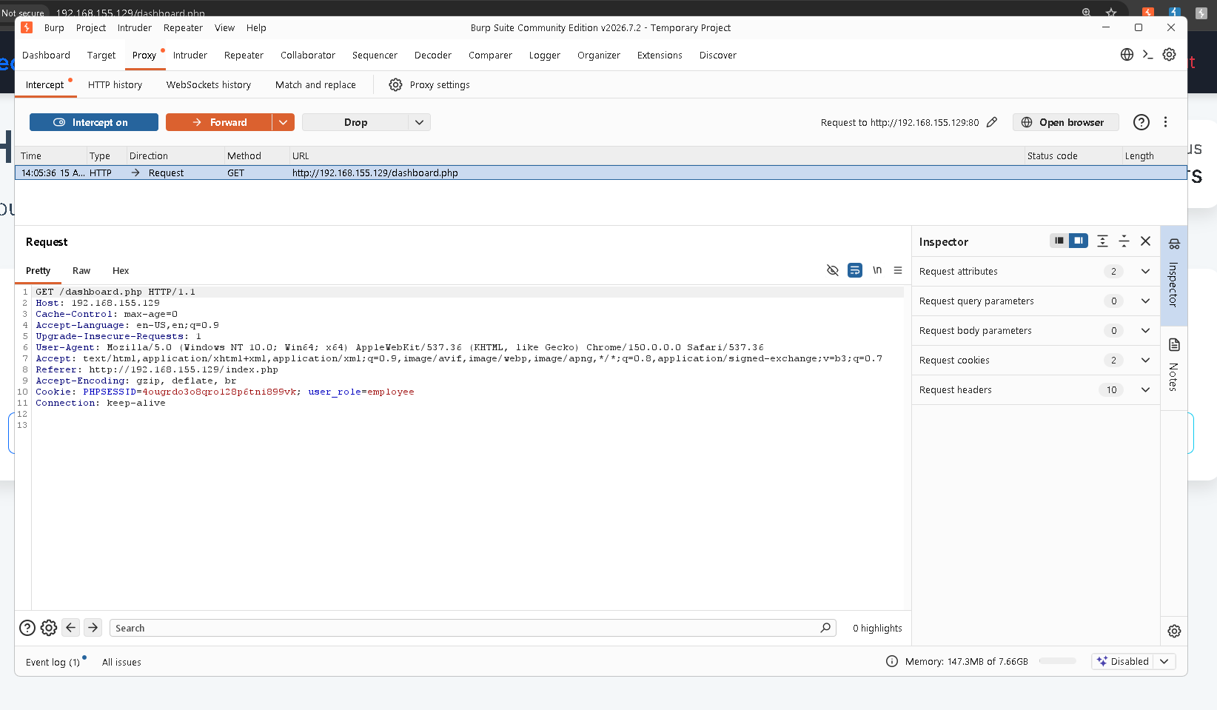
Fig. 5 — Intercepted GET /dashboard.php request revealing the plaintext user_role=employee cookie.
A dedicated, readable authorization attribute traveling as its own independent cookie — rather than being derived server-side from PHPSESSID against a session table — is the signature of an application trusting client input for access-control decisions.
STEP 4 Exploitation — Tampering With the Role Cookie
With the request held in Burp's Inspector, the user_role cookie value was selected for editing:
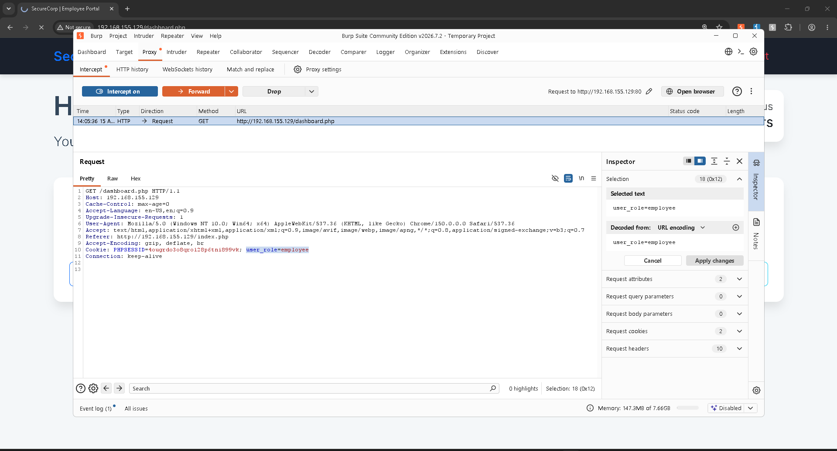
Fig. 6 — user_role=employee selected in Burp's Inspector panel, prior to modification.
The value was changed from employee to admin, leaving PHPSESSID and every other header untouched, then the change was applied:
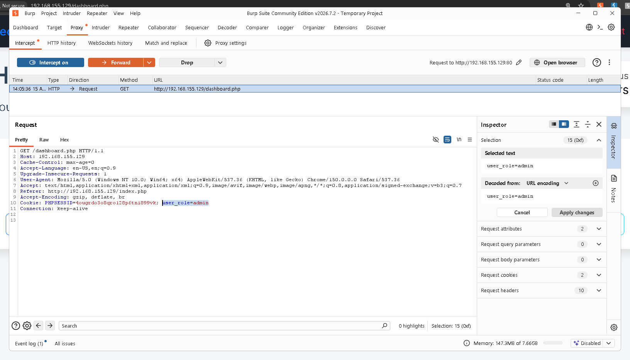
Fig. 7 — The same request after editing the cookie to user_role=admin, ready to forward.
STEP 5 Confirming the Escalation
The tampered request was forwarded to the server. No server-side re-validation rejected the modified value — the application rendered the dashboard as if the request had genuinely come from an administrator, surfacing a high-alert banner that had not been visible as “employee”:
FLAG{COOKIE_MANIPULATION_SUCCESS}
High Alert: User privilege escalation detected via cookie tampering. Admin Panel at Risk
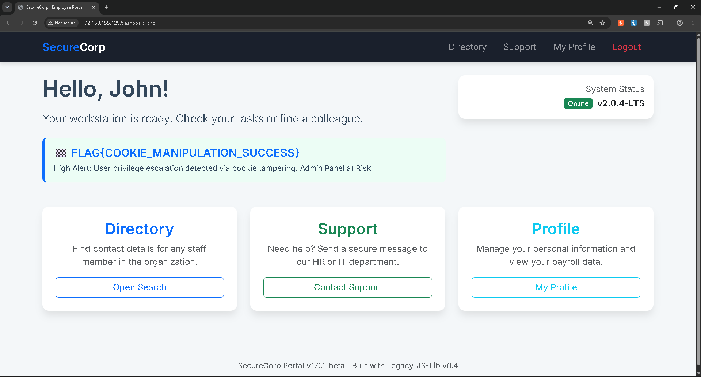
Fig. 8 — Dashboard re-rendered under the tampered cookie, exposing the flag banner.
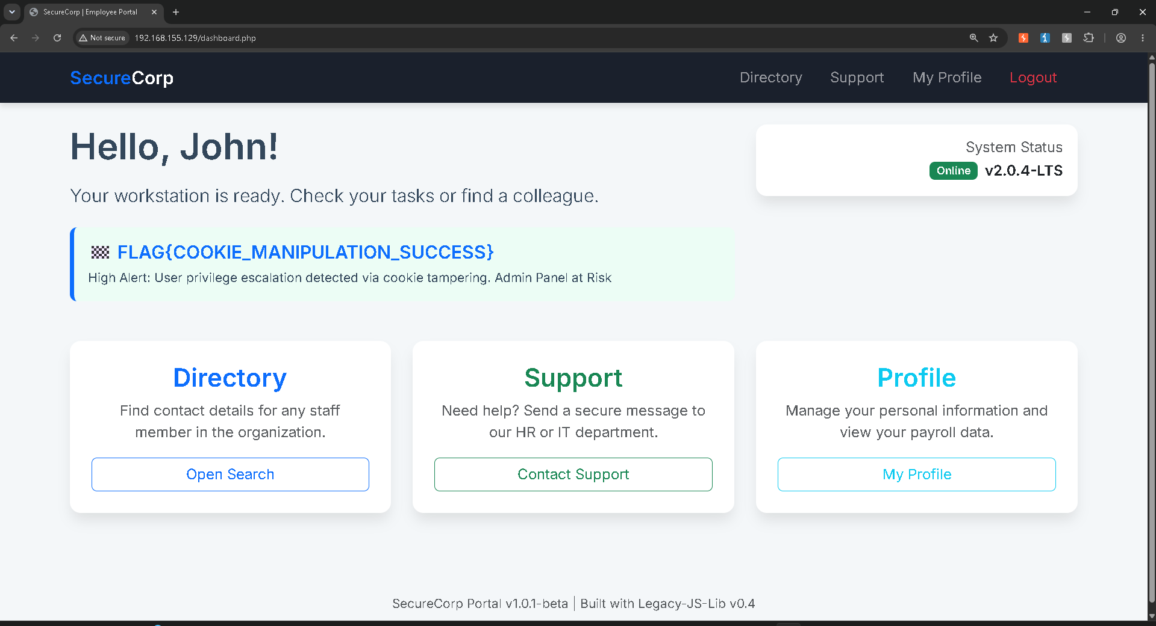
Fig. 9 — Confirmation view of the dashboard displaying the captured flag.
STEP 6 Flag Submission
FLAG{COOKIE_MANIPULATION_SUCCESS} was submitted to the lab platform's answer field and validated as correct, closing out the objective.
[ screenshot file not retained in upload — described from session capture ]
Fig. 10 — Flag accepted as the correct answer on the lab platform.

Root Cause Analysis
Authorization is decided from a value the client itself supplies and can freely rewrite. Nothing in the request ties user_role to the authenticated session: no server-side lookup against a session/user table keyed by PHPSESSID, no signature (HMAC) over the cookie, and no re-check against a database of actual role assignments. The server implicitly trusts whatever role the browser claims to have on every request, which is the definition of improper session/state management.

Impact
- Any authenticated user, regardless of real privilege, can self-escalate to administrator by editing one cookie value — no exploit chain, no timing, no rate-limit evasion required.
- The dashboard explicitly flags an “Admin Panel at Risk,” and the same portal exposes a payroll/profile section, implying escalation could expose other employees' personal and payroll data, plus directory records.
- Combined with Finding 2, the full path from zero access to administrator requires only: view page source → log in → flip one cookie.

Recommendations
- Resolve role/privilege server-side on every request by looking it up from a trusted store keyed by the session ID — never accept it as client-supplied input.
- If any role/state indicator must live in a cookie, protect its integrity with a server-held secret (signed/encrypted session token, e.g. a properly verified JWT or framework-managed session) so tampering is detected and rejected rather than trusted.
- Re-enforce authorization server-side on every privileged endpoint and page render, not only at login.
- Remove hardcoded credentials and onboarding notes from shipped markup; replace with a forced password-reset-on-first-login flow.
- Apply HttpOnly, Secure, and SameSite attributes to session-related cookies to reduce the broader theft/tampering surface.
- Upgrade or patch Legacy-JS-Lib v0.4, flagged in the portal footer as vulnerable to CVE-2021-XXXX, as part of the same remediation pass.

Conclusion
This engagement demonstrates a textbook Improper Session Management / Broken Access Control vulnerability (OWASP A01:2021): the server extends trust to client-controlled data for an authorization decision, and that trust is trivially abused to reach administrator context. Exploitation was fully reproduced and confirmed via the FLAG{COOKIE_MANIPULATION_SUCCESS} flag.

Appendix A — Evidence Index
Fig. | Source File | Contents
1 | Screenshot_2026-08-15_130412.png | view-source with credential comment
2 | Screenshot_2026-08-15_140327.png | Login form populated
3 | Screenshot_2026-08-15_140341.png* | Burp intercept enabled (not retained on disk)
4 | Screenshot_2026-08-15_140410.png | Intercepted login POST
5 | Screenshot_2026-08-15_140559.png | user_role=employee cookie
6 | Screenshot_2026-08-15_140615.png | Cookie selected pre-edit
7 | Screenshot_2026-08-15_140632.png | Cookie edited to admin
8 | Screenshot_2026-08-15_140644.png | Dashboard flag banner
9 | Screenshot_2026-08-15_142029.png | Flag confirmation view
10 | Screenshot_2026-08-15_142215.png* | Correct-answer confirmation (not retained on disk)
* Figures 3 and 10 were visible during the session but their image files were not retained in the upload set; their contents are described from direct observation.

Appendix B — Indicators / Key Values
Target | 192.168.155.129
Vulnerable Endpoint | GET /dashboard.php
Vulnerable Parameter | Cookie: user_role
Payload | user_role=admin (was: user_role=employee)
Disclosed Credentials | john : babayaga
Flag | FLAG{COOKIE_MANIPULATION_SUCCESS}

